Results

Sheet “2018”

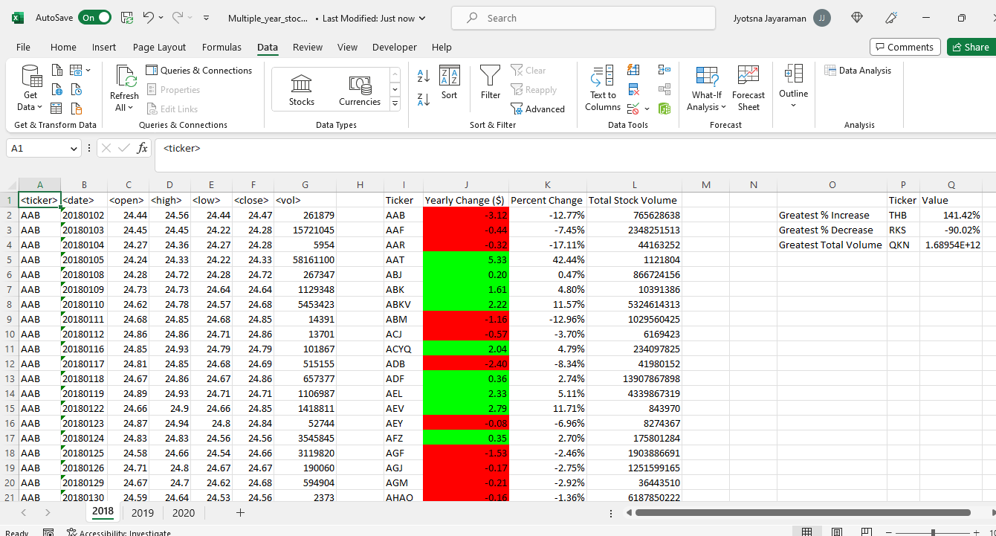

Sheet “2019”

Sheet “2020”

Note:

* 3000 unique ticker symbols were found in each sheet for which Yearly Change, Percent Change and Total Stock volume was appropriately calculated and populated in the same sheet.
* Yearly Change & Percent Change values have been appropriately Number formatted. Colour formatting of red or green is applied on values in Yearly Change column if they are less than or greater than 0 respectively.
* The "Greatest % increase", "Greatest % decrease", and "Greatest total volume" was calculated from the consolidated result table in each sheet and populated in the same sheet appropriately.
* The VBA code ran successfully across all three sheets which had data in the excel workbook.

Assumptions:

* The code will always be run against data which is sorted on <Ticker> followed by <date> column for each <ticker>